TRANSPORTATION |  | PROJECT REPORT
INITIAL PROJECT PROPOSAL  Month Year  Project Name  Project Type/Work Type  PIN XXXXXX  Route XXXX/BIN XXXXXXX Carried over Crossed  City/Town/Village of NAME  NAME County  Local Project Sponsor: NAME  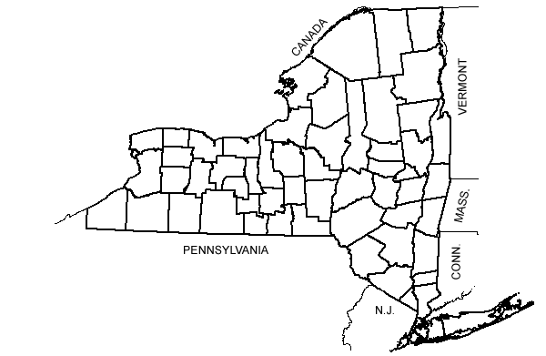 |  | PROJECT REPORT
 | 

This page intentionally left blank

PROJECT APPROVAL SHEET
(Pursuant to SAFETEA-LU Matrix)

Milestones | Signatures |  |  | Dates
A. Acceptance of IPP: | The IPP, as prepared in coordination with NYSDOT, is complete and correct according to the project application.
 | Responsible Local Official
B. Recommendation for IPP Approval: | The project cost and schedule are consistent with the Regional Capital Program.
B. Recommendation for IPP Approval: | Regional Planning and Program Manager
C. IPP Approval: | The project is ready to be added to the Regional Capital Program and project scoping can begin.
C. IPP Approval: | Regional Director

This page intentionally left blank

PIN: XXXX.XX

PROJECT NAME: Project name and type

MUNICIPALITY: City/Town/Village COUNTY: County

ROUTE(S): Road name(s); include State SH#(s) if applicable

BIN(s): Bridge number(s) and feature carried/crossed

LIMITS: Project termini
(include NYSDOT Milepoints and Reference Markers if applicable)

GIS Identifier(s): segment XXXX from milepoint XXXX to XXXX (to be supplied by DOT)

For projects with multiple locations, attach Cost Breakout Sheet:

PROJECT LENGTH: XX.XX CENTERLINE MILES XX.XX LANE MILES

FEDERAL AID SYSTEM: NHS or Non-NHS or Not FA-eligible road

FUNCTIONAL CLASS: Number(s) and description(s) by highway segment

EXISTING AADT: XXXX (year) PERCENT TRUCKS: XX

EXISTING CHARACTERISTICS OF CONCERN: (list and describe applicable elements)

ELEMENT MEASURE/INDICATOR
Bridge(s) Condition Rating = XX.X; Sufficiency Rating=XX.X
List deficient structural element with rating.
Required repairs are beyond the capabilities of Department Maintenance forces.

Pavement Rating Surface score= X, Indicate dominant distress

Accidents XX ACC/MVM, Statewide Average=XX ACC/MVM

Traffic Signal Deficiencies

Other Pertinent Measure(s)

PROBLEM DESCRIPTION: Describe the problem(s) in more detail and its effect on the transportation system

PROJECT OBJECTIVE(S): Project objectives are what the project is meant to accomplish; the desired results of the project; the outcomes of the project that meet the identified needs or remedy stated problems. Therefore, objective(s) will be unique to each project.

Project objectives provide evaluation criteria (measures of effectiveness) for comparing how well alternative solutions fulfill identified needs. Objectives should be listed or grouped in order of importance.

PROJECT ELEMENT(S) TO BE INVESTIGATED: Check all that may apply. Refer to the Highway Design Manual to determine 1R, 2R, & 3R highway project category.

 | Deck Replacement |  | Bridge Replacement, New Alignment
 | Minor Bridge Rehabilitation |  | Bridge Replacement, Existing Alignment
 | Major Bridge Rehabilitation
 | 1R Highway Resurfacing |  | 3R Highway Reconstruction
 | 2R Highway Restoration
 | Appurtenance Only |  | Traffic Control
 | Large Culvert Repair |  | Large Culvert Replacement
 | Other: sidewalks, shared use path, etc. (describe)

PRIORITY RESULTS: Mobility & Reliability Safety Security
Economic Competitiveness Environmental Stewardship

FUNDING SOURCE: 100% State Federal (Source: XXXXXXXXX)

ENVIRONMENTAL RECOMMENDED CLASSIFICATION:
PROJECTED ENVIRONMENTAL PROCESS:
NEPA |  | No Federal |  | Class II, CE |  | Class III, EA |  | Class I, EIS
 |  | Funds |  | C-list |  | SAFETEA-LU |  | SAFETEA-LU
 |  |  |  | D-list |  | Applies |  | Applies
 |  |  |  | with doc.
SEQR |  | Exempt |  | Type II |  | Non-Type II |  | Type I
 | Not for local proj’s |  |  | Unlisted – No  Effect |  | EA |  | EIS  Neg Dec

The following checklists are attached:
Environmental Checklist
Smart Growth Screening Tool
Complete Streets Checklist

MPO INVOLVEMENT: No Yes TIP Name: XXXXXXXXXXX
TIP No.: XXXXX

TIP AMENDMENT REQUIRED: No Yes-Needed by: XXXXX

STIP STATUS: On STIP Not on STIP

NOTES ON SPECIAL CIRCUMSTANCES: Describe (public sensitivity, environmental, cultural/ historic resources, political commitment, relation to other projects, etc.)

SPECIAL TECHNICAL ACTIVITES REQUIRED: Describe

PLANNED PUBLIC INVOLVEMENT: Note meetings/hearings and time frames

PROBABLE SCHEDULE AND COST:
DESIRED LETTING: Month Year

SCHEDULE ISSUES: Public Hearing Section 4(f)/106 Resources
Major Permits Other issues: Describe
Consultant(s) for: Describe
or No consultant needed

Project  Phase | Activity  Duration | Estimated  Cost | Fund  Source | Obligation  Date
Scoping
Preliminary Design I-IV
Final Design V-VI
ROW Incidentals
ROW Acquisition
Construction
Construction Inspection
TOTAL

BASIS OF ESTIMATE: Explain. Attach estimate.

PROGRAM DISPOSITION: Scheduled for letting in _____________ (to be added by Planning)

PROJECT CATEGORY: Simple Moderate Complex

STATEWIDE SIGNIFICANCE: No Yes
Remarks:

SPONSOR’S PROJECT MANAGER: Name, Title
FUNCTIONAL AREA: Division/Department
PHONE: Phone/Email

NYSDOT LOCAL PROJECT LIAISON: Name
PHONE: Phone/Email

IPP PREPARED BY: Name, Title
DATE: Date

IPP Shell updated 2-28-2018 by Dave MacEwan

